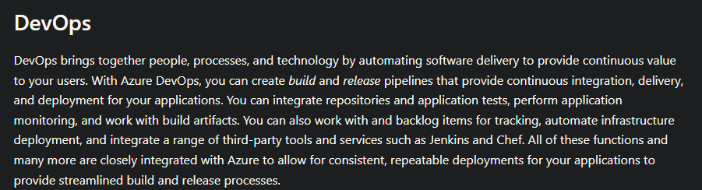

https://docs.microsoft.com/en-us/learn/modules/intro-to-azure-fundamentals/tour-of-azure-services

Azure Fundamental

1. What is CI / CD? What Azure resources can we use to set up and implement CI / CD in our work environment?
2. What are two different ways to use Azure Redis Cache? Give an example for each method.
3. We want to monitor our application and collect metrics such as service availability and API response times. How can we do that?
4. Azure apps oftentimes still need some form of authentication to access other resources (ex. API keys, email passwords, etc.) However, we cannot hardcode these values into our application due to security reasons. What are some ways to get these confidential values without hardcoding them into our application?
5. Our application needs a data store. What are some options we can use and what are some advantages / disadvantages?
6. You plan to deploy several Azure virtual machines. You need to ensure that the services running on the virtual machines are available if a single data center fails. What settings should you do?
7. What is Azure app service plan? What can be set via app service plan?
8. What are the differences between Azure App Services and Azure Virtual Machines?
9. You developed a new feature in your project and now want to deploy it to your development environment running in Azure Kubernetes Service (AKS) for further testing. How would you use Azure resources to automate this process? Briefly explain what each component does in your flow.
10. Azure IaaS, PaaS, SaaS What layer do you manage or provider manage(Applications, Data, Runtime, Middleware, OS, Virtualization, Servers, Storage, Network)? Which level is Azure Virtual Machine, Azure Key Vault, Azure Container Registry, Azure PostgreSQL DB, Azure Redis Cache, App Service, Outlook email